**Annual Report of the General Committee**

***on the work of Goldsmiths Community Association***

***and its activities during the past year.***

AGM Saturday 25th January 2020 3pm

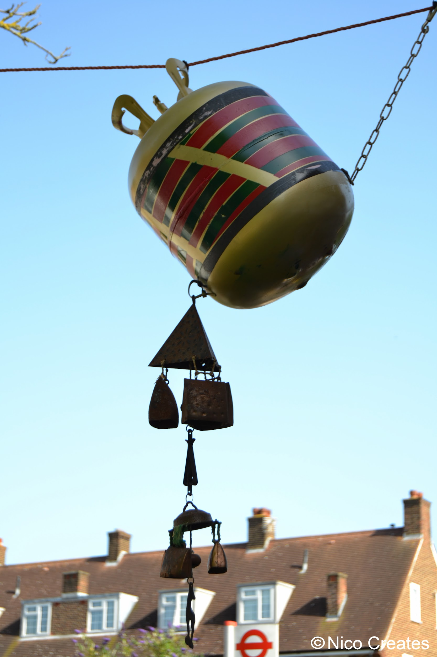



**Goldsmiths:**

***Putting the Centre back into our community***

**Association objectives**

“To promote the benefit of the inhabitants of Downham and Hither Green and the neighbourhood … in a common effort to advance education and to provide facilities in the interests of social welfare for recreation and leisure­ time occupation with the object of improving the conditions of life for the said inhabitants.” *(GCA constitution par. 2a,* *emphasis added.)*

**Governance**

**GCA Trustees (December 2018-December 2019)**

| Alan Till | Chair |
| --- | --- |
| Elizabeth Wood | Vice Chair, Service provider |
| Susanna East | Treasurer, local resident |
| Cllr Mark Ingleby | Ward Councillor, local resident |
| Charles James | Service User, Lawyer |
| Shipra Ogra | Service User, local resident |
| Israel Oyebamiji | RCCG Pastor, local resident |
| Liezel Sprately | Service provider, Appointed September 2019 |

**Current Staff**

Darren Taylor - Business Development Manager (appointed November 2019)

Brian Gregory, Premises Officer

Jade Nembhard - Operations Manager

Dione Swain & Dawn Fiorentini - Operations Duty Officers

Fiorella Fronzi - Apple Tree Cafe Manager (appointed February 2019)

Roz Hardie - Whitefoot Ward Community Development Worker (funded by LBL) (maternity cover for Sara Wickert)

Assisted by a strong and able team of volunteers from our local community

**Chairs’ Report 2019**

This last year in the main has been a very positive one for Goldsmiths as we continue to play a vital role in our community.

The Apple Tree Cafe and our community shop opened, serving good food and bargains for all. Many thanks to Downham Nutritional Partnership and other funders for their financial help in setting up the cafe and for their involvement now and in the future .

Many community groups and hirers are now using the Centre but we must endeavour to get more usage and increase our applications for charitable funds so that we can generate sufficient income to keep user costs down but still be viable and accessible to the whole community.

Thank you to all of our dedicated staff and volunteers without whose efforts we would not exist and Thank You to the Trustees who have the responsibility of running Goldsmiths and having to make, at times, very difficult decisions.

We are very fortunate in having this facility here in North Downham. Goldsmiths Community Centre is a wonderful Community Asset, but it receives little or no regular grant input towards upkeep and running costs, so it needs to be well used and supported by us all.

Thank you for attending today and lending your support to Goldsmith's Community Association

**Treasurer’s Report 2019**

The accounts for the 2018-19 fiscal year show a surplus for the year which can be attributed to the considerable efforts of staff, volunteers and trustees to achieve an increase in income from the hire of premises. This surplus is reduced from the previous year as expenses increased to support the growth. We have continued to grow through 2019, the surplus from the past two years will cushion the deficit that is forecast for the current financial year.

Ambitions for the Association and the Centre are high and GCA trustees recognise that, in order to continue to achieve the objectives of the Association, and to secure the Centre’s future as a sustainable community asset will require further investment into staff and other running costs. At the same time trustees have identified a need to move away from an over-reliance on weekend party hire income and to implement a more business focused approach to secure our long term future.

In these times of austerity there is little public funding available to support the running costs of facilities such as ours - the grant we receive from London Borough of Lewisham is directly linked to the employment of the Whitefoot Ward Community Development Worker, a highly valued role which enables GCA to achieve many objectives both within and beyond the Centre. It is, therefore, necessary for the management team to explore alternative ways of achieving regular and sustainable income in order to achieve full financial stability. During 2019 the Operations team have successfully embedded several processes to improve the efficient running of the Centre and service provided to users. Our new Business Development Manager has identified actions to further improve efficiencies as well as potential partnerships and funding sources towards running costs.

I anticipate many challenges and changes during 2020 but feel confident that the team of staff, trustees and volunteers at GCA have the skills and commitment to achieve a secure future.

**2019 was a busy year at Goldsmiths!**These images give an idea of just some of the wonderful activities and events during 2019.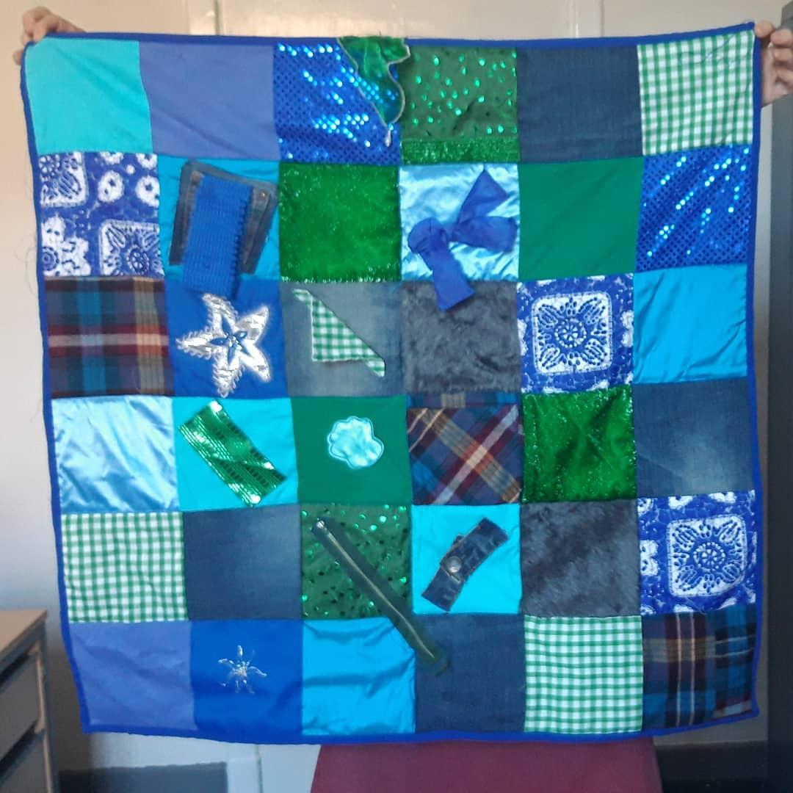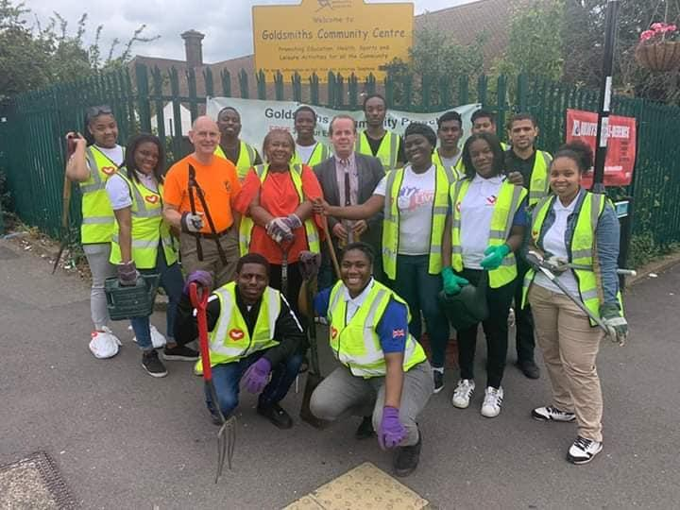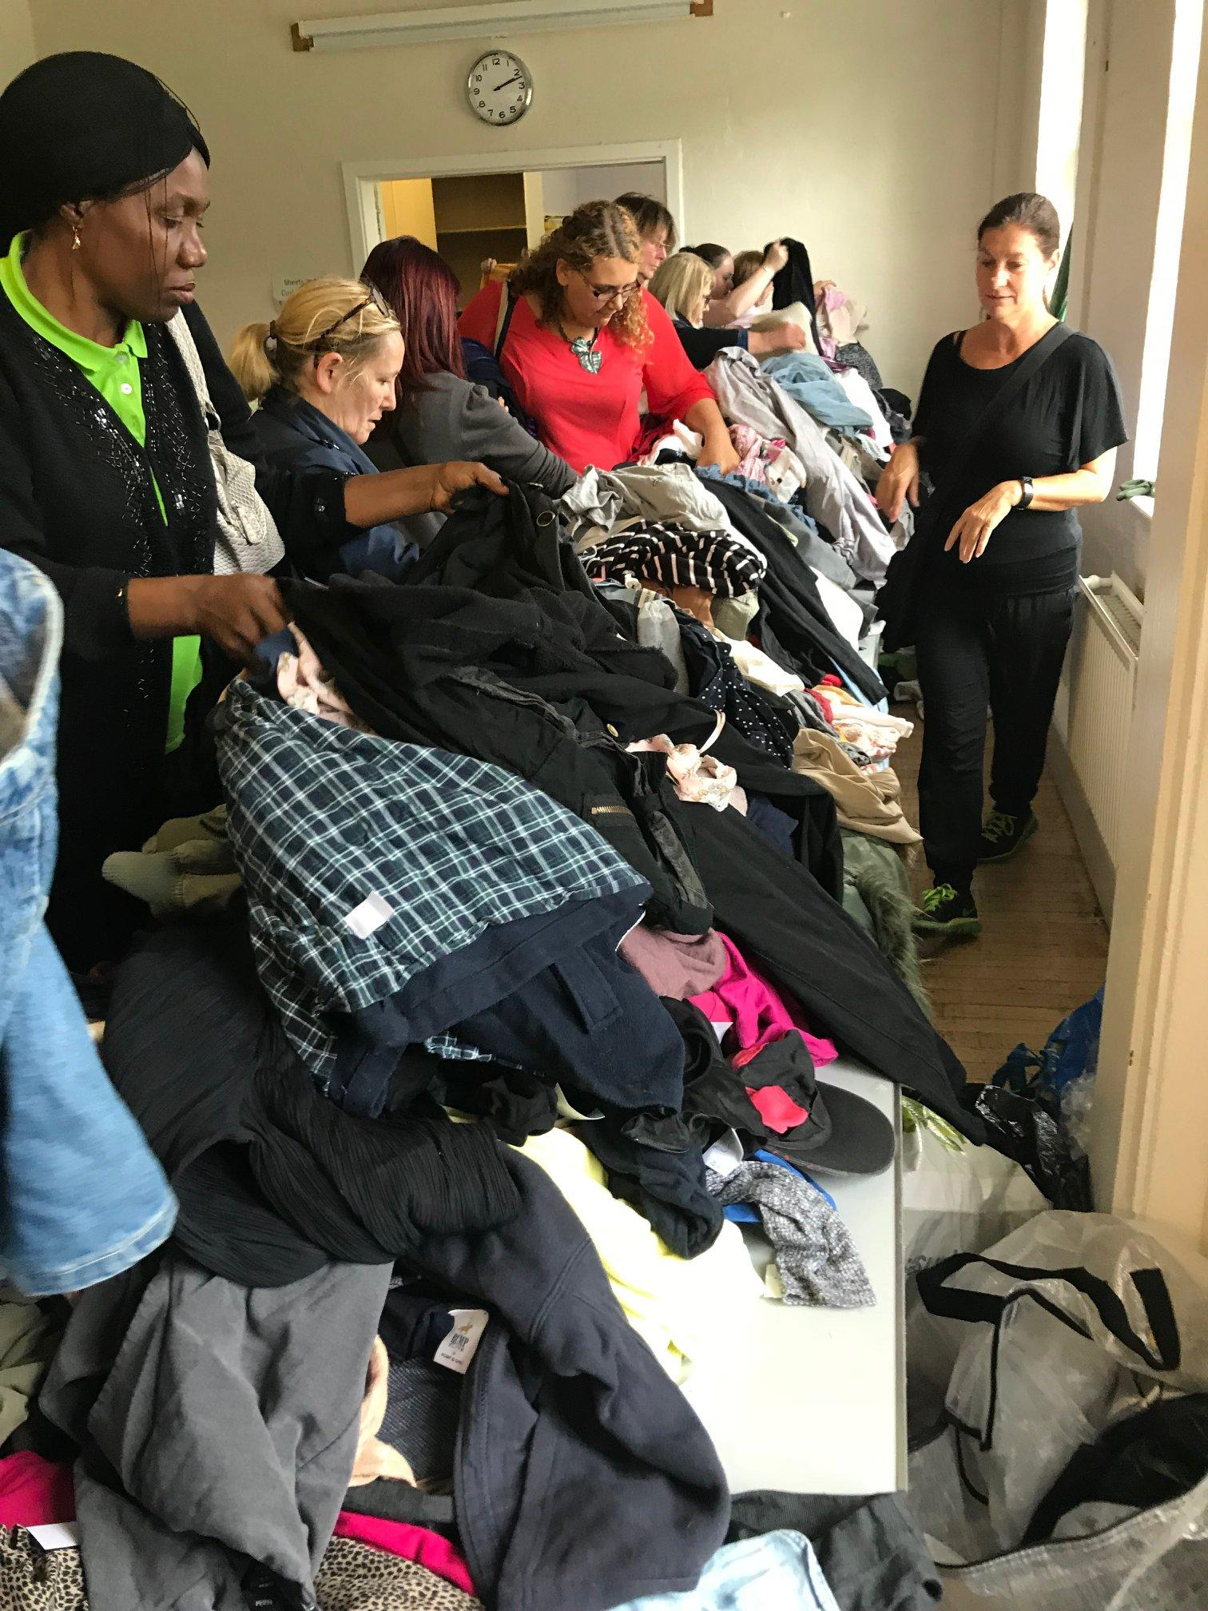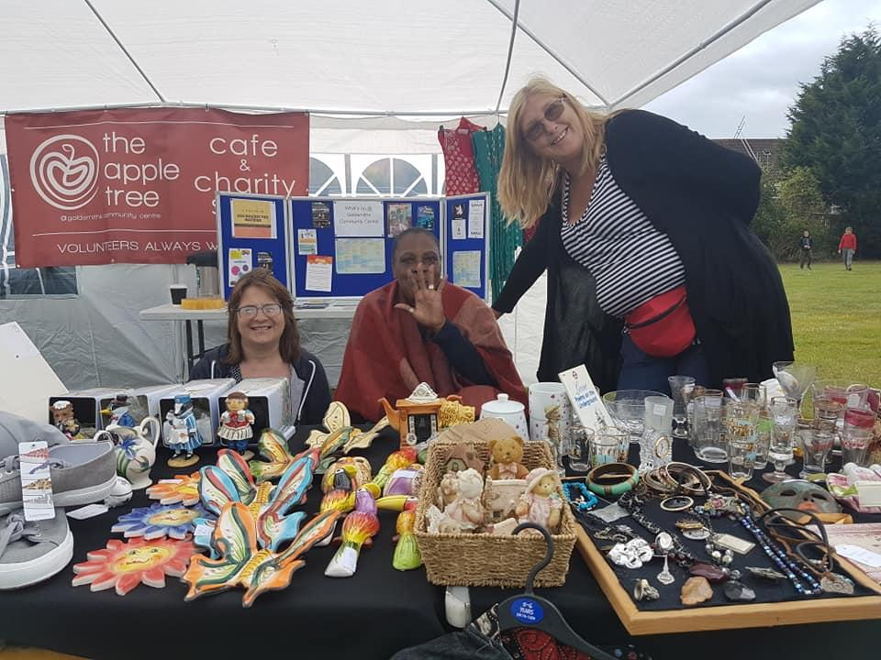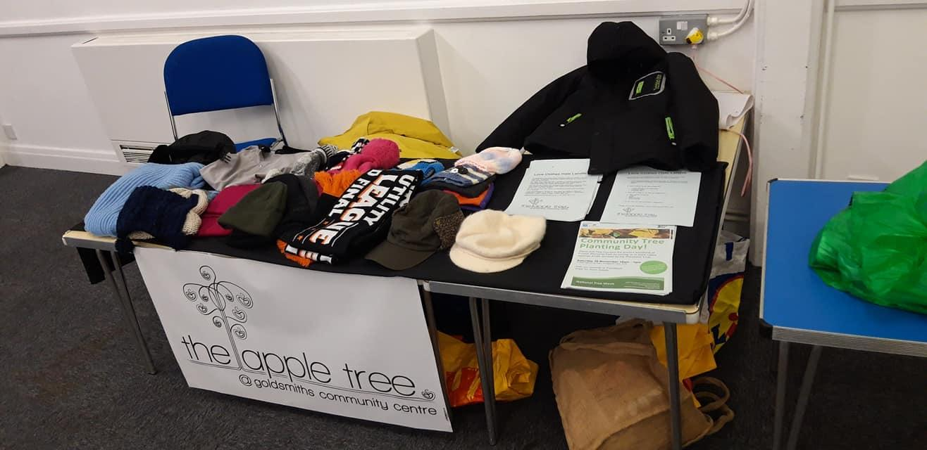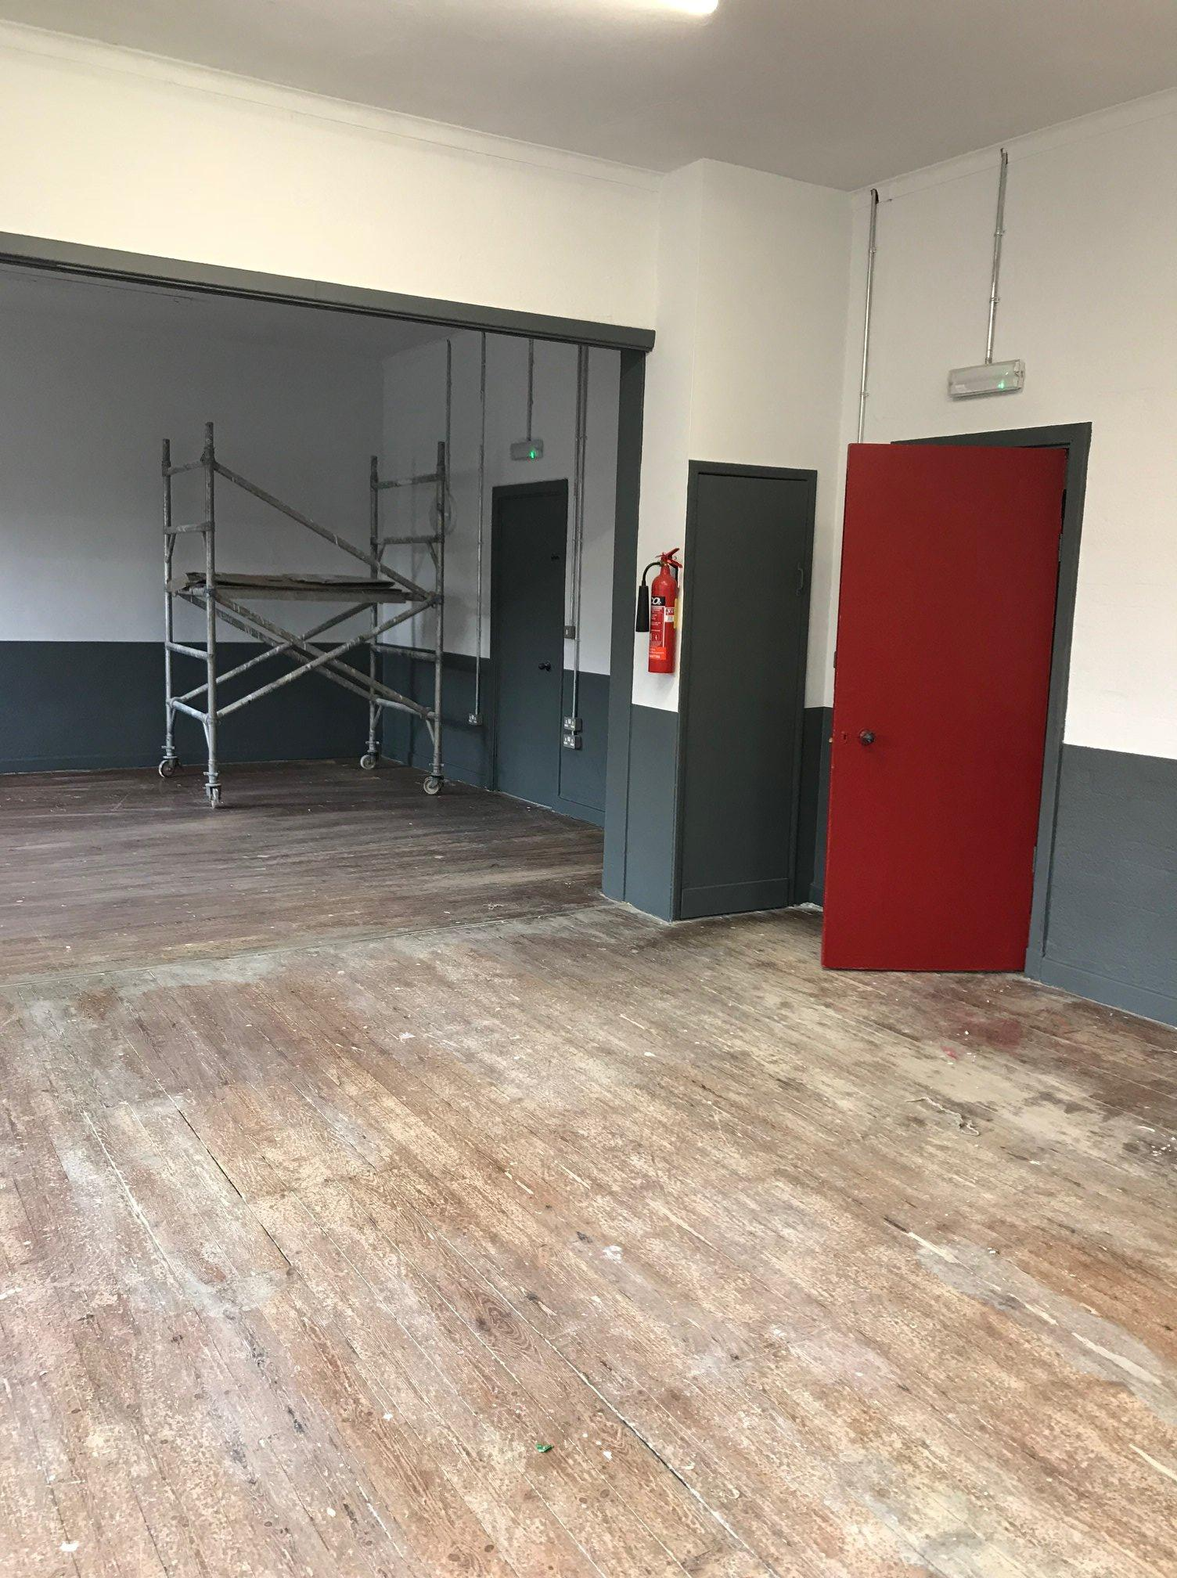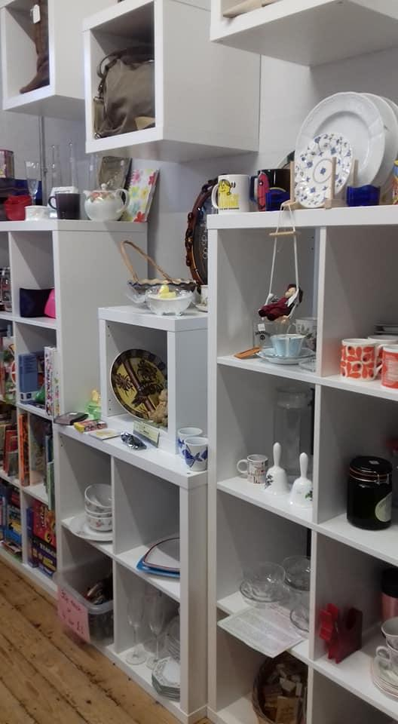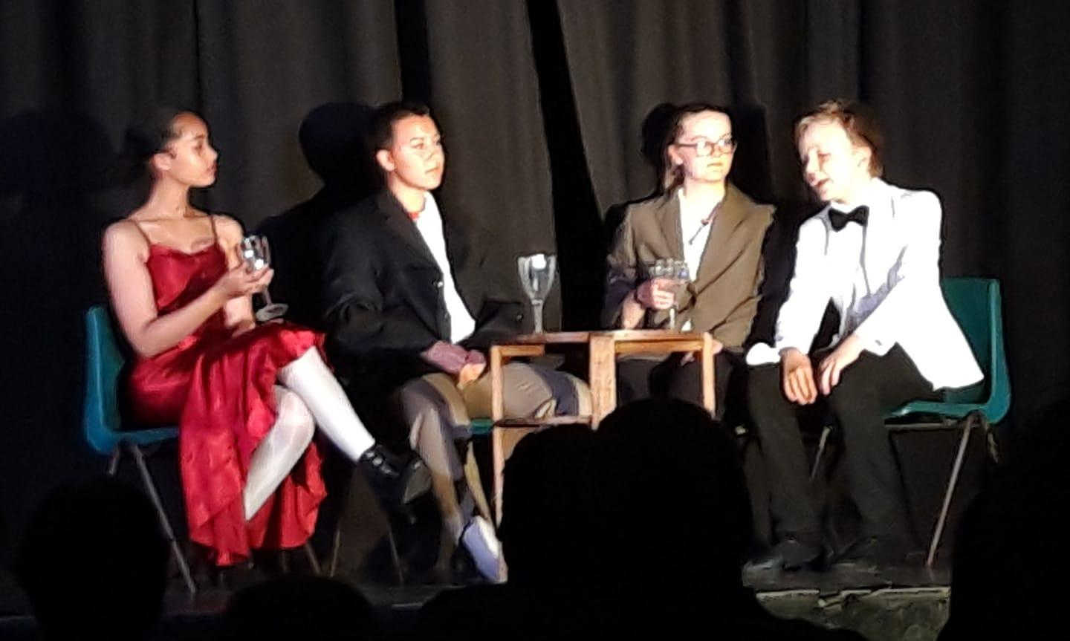

On behalf of our local community the trustees at GCA would like to express our gratitude to the brilliant team of staff and volunteers for making the wonderful events featured (and so much more) possible.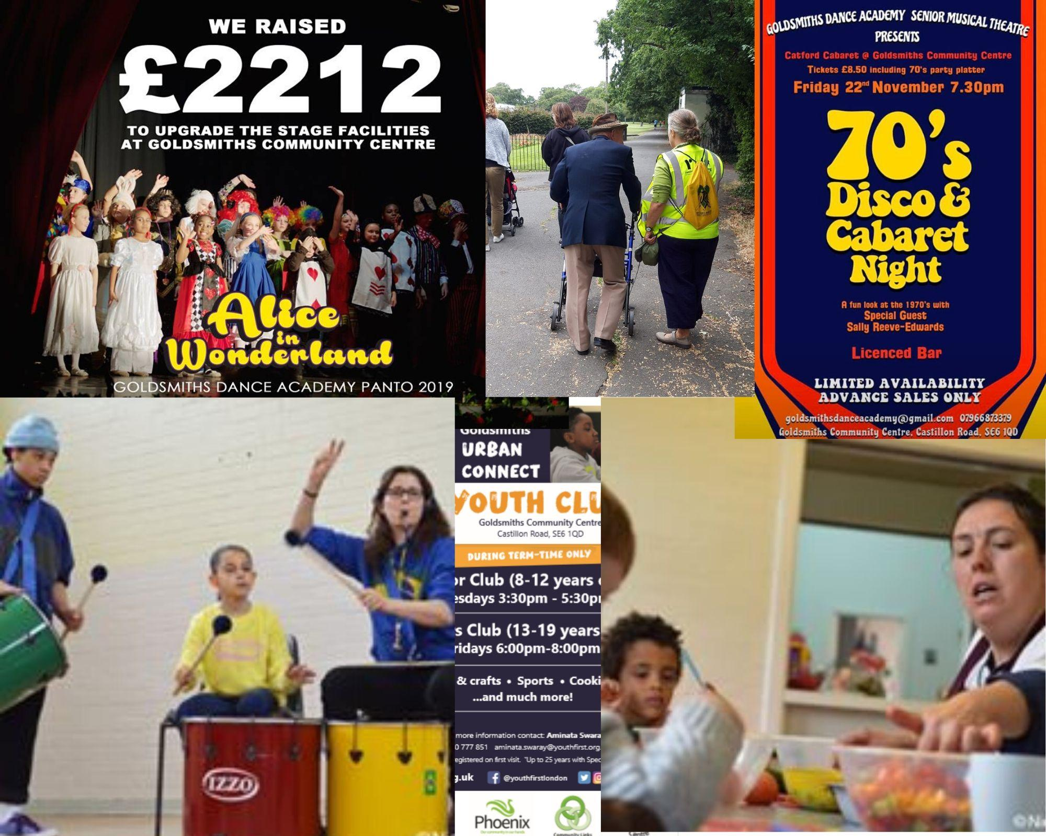

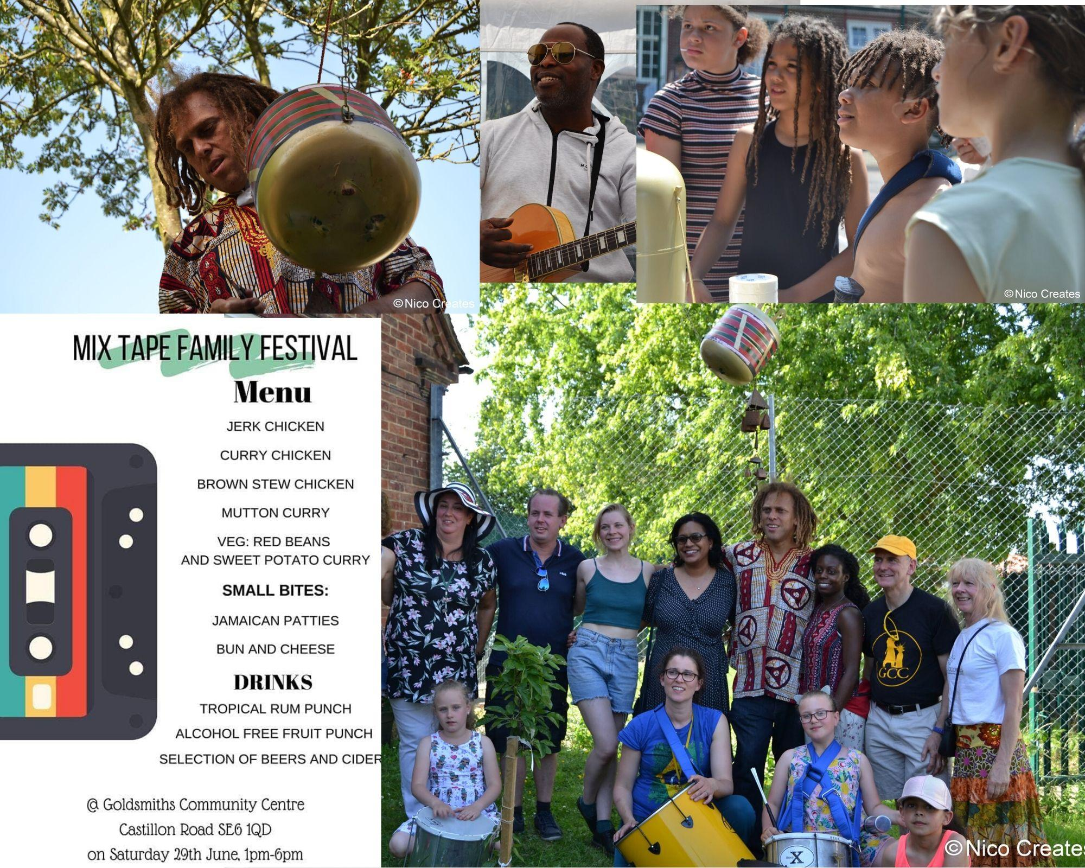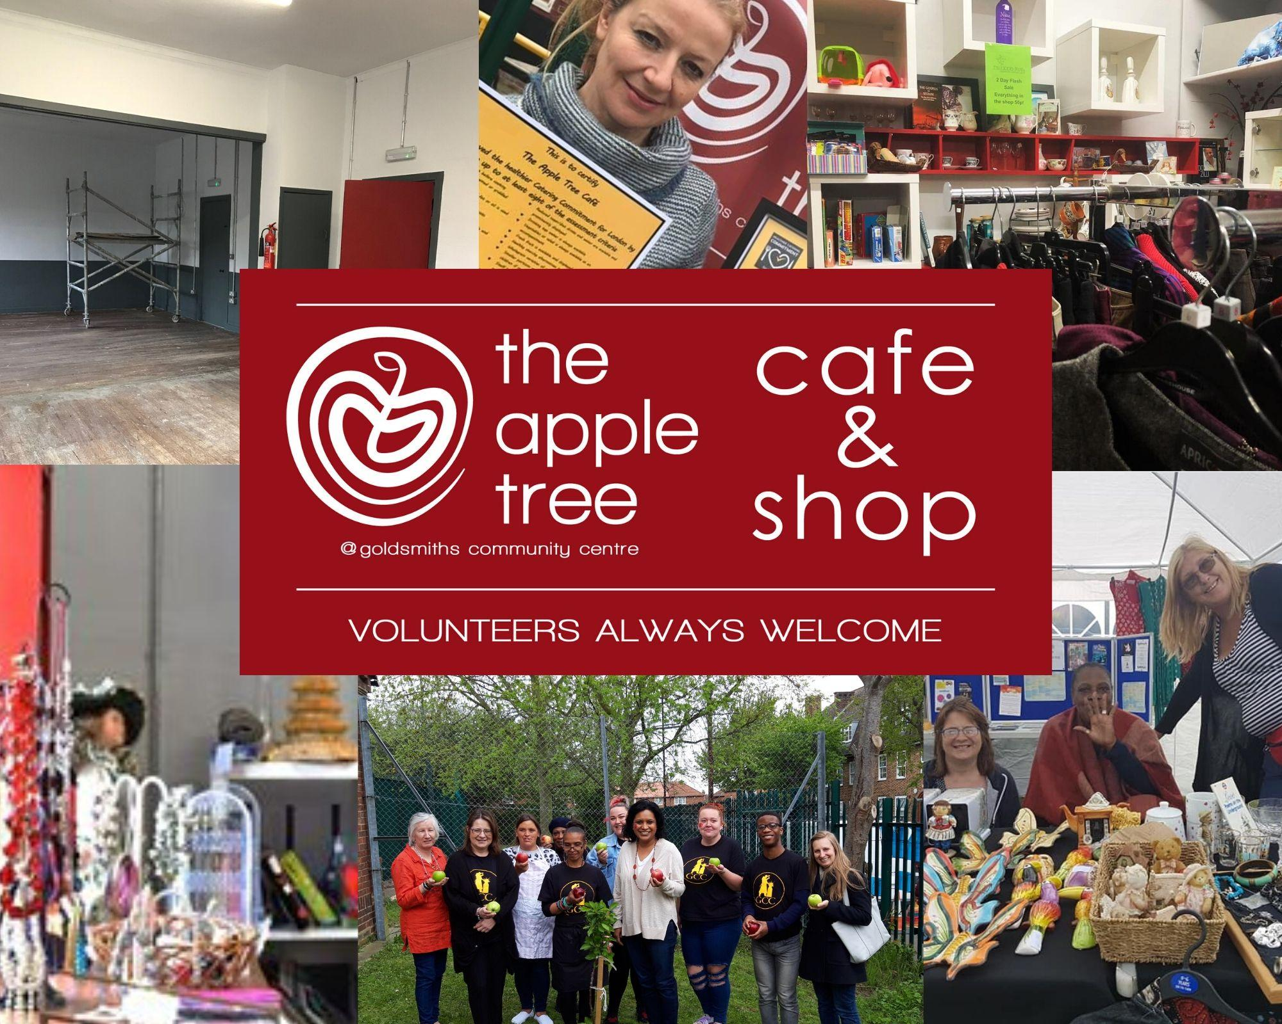

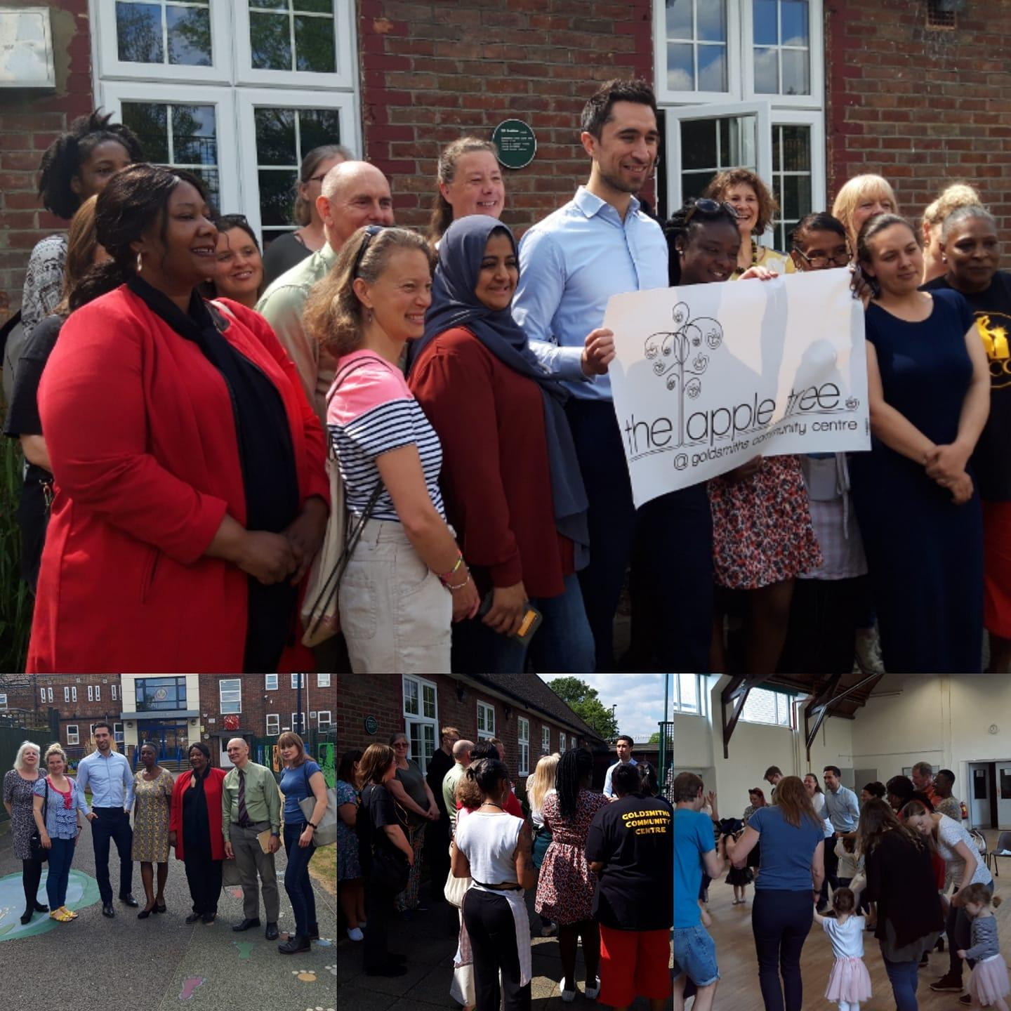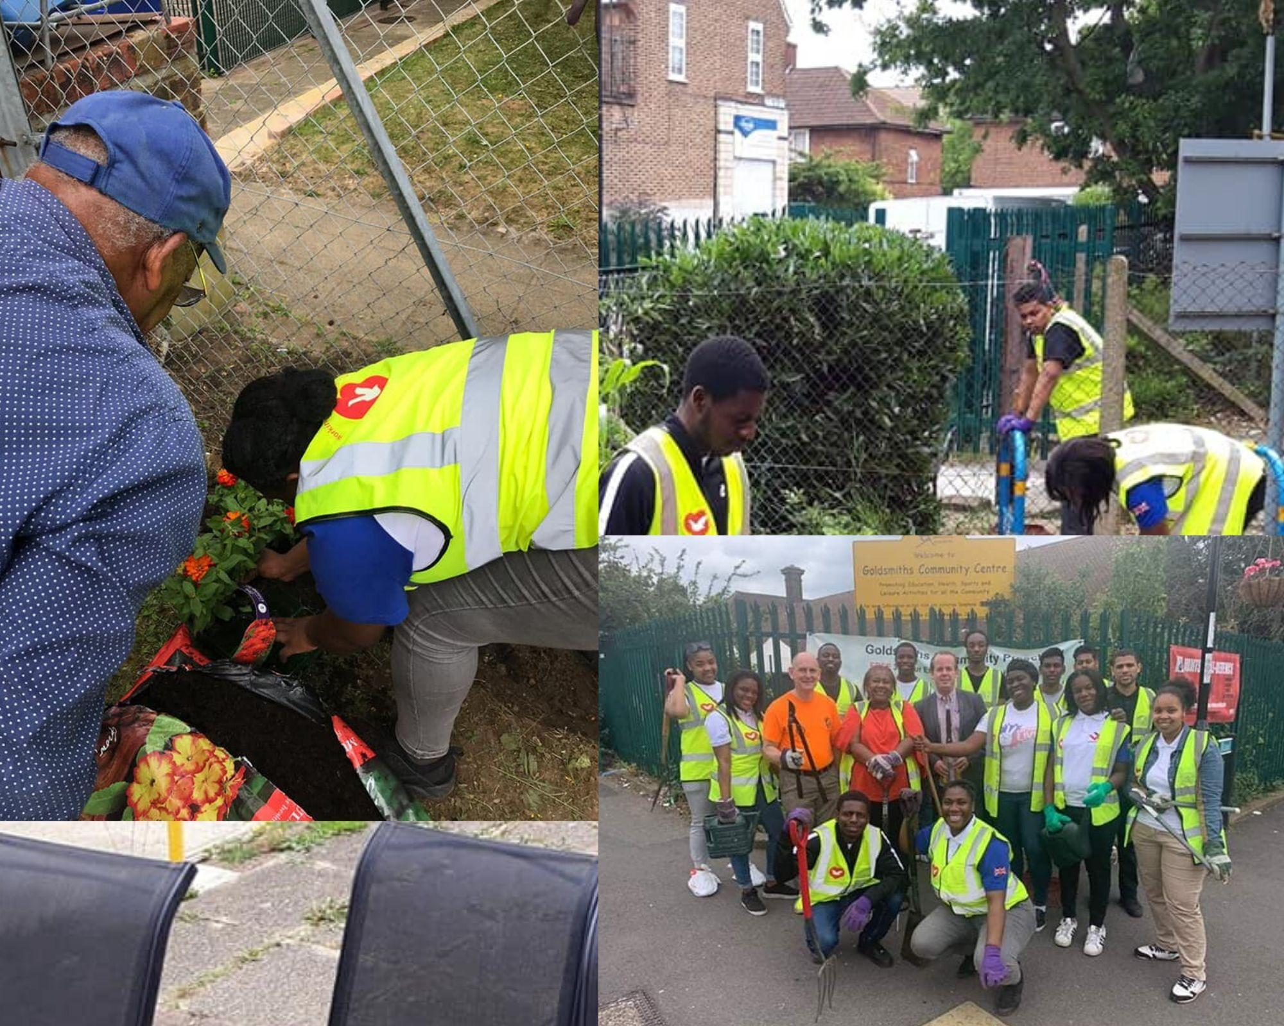

Acknowledgements and thanks:

There is a large community of people and organisations to thank for supporting the work of the Centre and the Association. Please accept apologies for any unintentional omissions from this list:

The reliable team of GCA volunteers who give their time so generously - we would be lost without you!

Lewisham Police Cadets - who attend and support so many events and take on a variety of tasks with a willing hand and winning smiles

DNP for financial contribution and support in shaping the Apple Tree project

Hunters Catford for sponsoring our Christmas Fair

Lewisham Arts Festival Fund supporting our Mix Tape Family Festival

Phoenix Community Chest funding for Urban Connect Youth Club

Downham Men’s Group for support to maintain the building and gardens

Goldsmiths Dance Academy for significant contribution to fundraising events

Goldsmiths Community PreSchool

Whitefoot Ward Councillors

All GCC User Groups

Our neighbours for their continued support

Our dedicated team of staff and trustees





*Coming soon….*

*Dementia Lap Quilt Making @ Goldsmiths Community Centre*

Join us for this fun & interactive new project making small 'fiddle quilts' entirely with recycled fabrics from our Apple Tree charity shop.

Never picked up a needle or used a sewing machine before? - no problem!

Previous sewing experience?- we need you!

Something for everyone and all ages welcome!

Free Sessions:

Commencing 24th February on:

Mondays 6.30 -8.30 pm

Tuesdays 11am-1pm - includes a light lunch

To get involved & more information email: **liz@goldsmithscommunitycentre.org.uk** 

or drop into the centre to find out more!